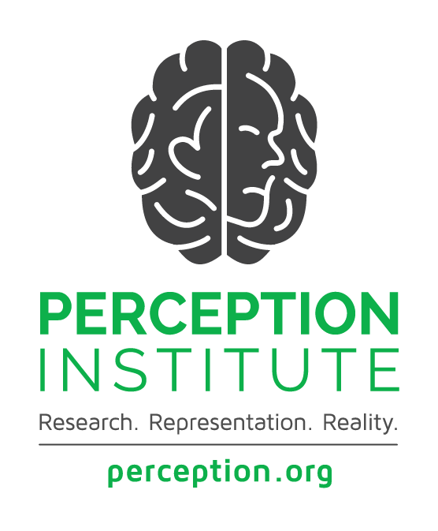

MIND SCIENCES INTERVENTIONS

**Implicit Bias Interventions**

“De-Biasing” – Efforts to Reduce Implicit Bias (i.e. “break the prejudice habit”)

*Stereotype Behavior Replacement*: Recognize when a response is based on a stereotype, label the response as stereotypical, reflect on why the response occurred, and consider how this biased response could be avoided in future. Replace the biased response with one that is consistent with egalitarian values.

*Counter-stereotypic imaging*: Imagine, in detail, counter-stereotypic others. These individuals can be real, fictional, or imagined. The strategy makes these images more readily available and useful for countering stereotypes.

*Individuation:* Gather specific information about individuals, in order to prevent making stereotypic inferences. This strategy helps people evaluate others based on personal, rather than group-based, attributes.

*Perspective Taking:* Imagine oneself to be a member of a stereotyped group. This increases empathy toward the group and reduces automatic group-based evaluations.

*Increase Opportunities for Contact*: Seek opportunities to encounter and engage in positive interactions with others. Contact decreases bias by altering mental representations of the group and improving evaluations of the group.

Break the Link Between Bias and Behavior

*Doubt Objectivity:* Presuming oneself to be objective actually increases the role of implicit bias. Acknowledge the presence of bias in order to counter its impact.

*Increase Motivation to be Fair*: Being internally motivated to be fair, rather than fear of external judgments, tends to decrease biased actions.

*Improve Conditions of Decision-making*: Think slow. Engage in mindful, deliberate processing to prevent implicit biases from kicking in and determining behaviors.

*Count:* Use data to detect biased behavior. Data can reveal racially disparate outcomes and help to identify patterns of behavior that may contribute to disparities.

**Reducing Racial Anxiety**

*Increase Intergroup Contact:* Direct interaction between members of different racial groups can alleviate inter-group anxiety, reduce bias, and promote more positive inter-group attitudes and expectations for future contact.

*Positive priming:* Thinking about prior positive inter-group contact before a new inter-group interaction can help to facilitate a more positive experience in that new interaction.

*Scripts:* develop a script for particular interactions that you know are likely to trigger anxiety. Knowing what to say allows people to focus on the other person.

*Learn triggers and acknowledge mistakes:* Certain words or phrases are likely to trigger racial anxiety because they are rooted in subtle stereotypes.

**Stereotype Threat Interventions**

*Belonging*: Increase the sense of belonging for individuals in stereotyped groups. Recognizing and celebrating varied identities allows everyone to be their full self, and makes identity less salient as a marker of difference.

*Stereotype inoculation*: Increasing the number of members of underrepresented groups in the workplace leads to greater social belonging and resilience among those underrepresented. In particular, exposure to successful people in positions of authority undermines stereotypes and increases motivation and a sense of self-efficacy for other group members.

*Successful task strategy:* Working harder does not decrease stereotype threat, but having clearly defined goals and strategies can. Research shows that those who are told explicitly about stereotype threat can develop a strategy to counteract it and thereby improve performance.

*Growth Mindset*: Abilities can be conceptualized as either fixed (“you have it or you don’t”) or able to be developed (“you can learn it”). When thought of as fixed, poor performance is equated with inadequacy, but with growth mindset, there is just more work to do.

*Wise Feedback:* Give feedback that communicates both high expectations and a confidence that the individual can meet those expectations. To ensure effective cross-racial feedback, research recommends: 1) Invoke high standards; 2) Provide reasons why this particular person is capable of meeting those standards; and 3) Offer candid feedback on how to achieve the standards.

Sources: Godsil et. al, *Science of Equality*, *Vol 1 (2014) & Vol 2 (2016)*

https://perception.org/publications/